Lab Plan No.2 Name: Muhammad Faizan Reg No.21-NTU-CS-1258

# Question No 1

## Input:

#include<iostream>

using namespace std;

int main()

{

cout<<"Conditional statement is written as;\n \"if(a==1)\n cout<<\"The value of a\"<<\"=\"<<a;\"";

return 0;

}

## Output:

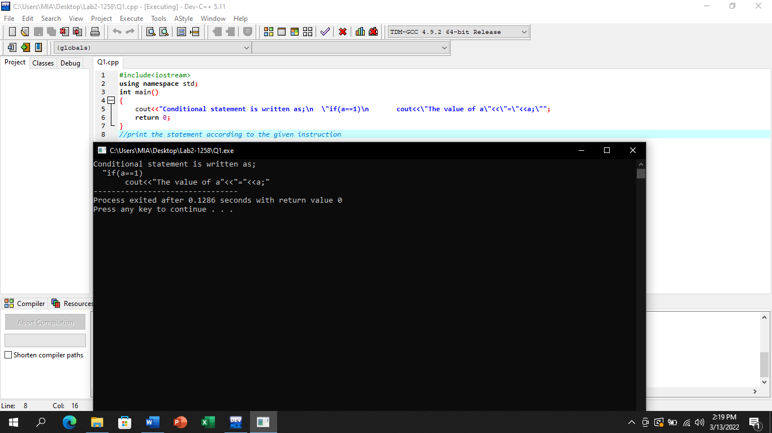

# Question No 2

## Input:

#include <iostream>

using namespace std;

int main()

{

int a,b,c;

cout<<"Input three different integers: ";

cin>>a>>b>>c;

int sum;

sum=a+b+c;

cout<<"Sum is "<<sum<<endl;

int average;

average=(a+b+c)/3;

cout<<"Average is "<<average<<endl;

int product;

product=a*b*c;

cout<<"Product is "<<product;

return 0;

}

## Output:

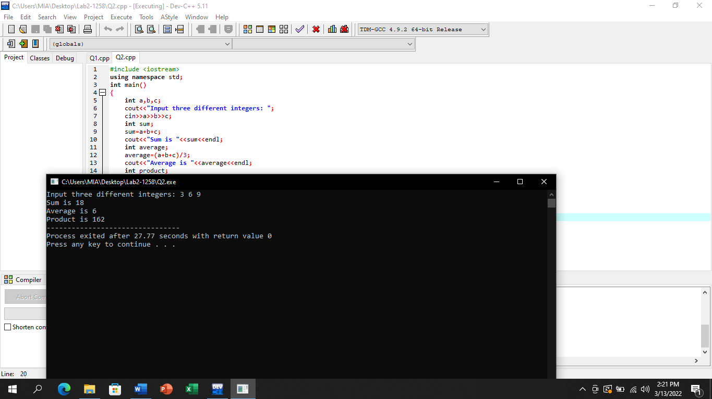

# Question No 3

## Input:

#include<iostream>

using namespace std;

int main()

{

int a,x,y;

cout<<"Input value of a: ";

cin>>a;

cout<<"Input value of x: ";

cin>>x;

y=a*(x*x*x)+(a*a)*(x*x)+x-7;

cout<<"y= "<<y;

return 0;

}

## Output:

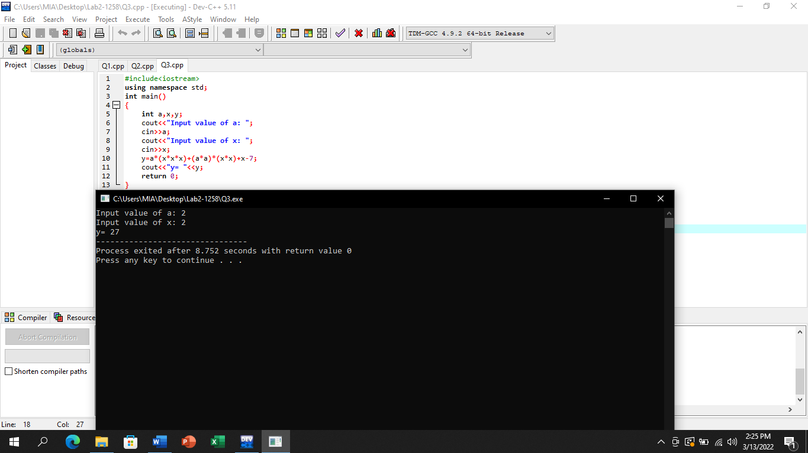

# Question No 4

## Input:

#include <iostream>

using namespace std;

int main()

{

float miles, kilometer;

cout<<"Enter value in miles: ";

cin>>miles;

//1 kilometer=0.6213 miles

kilometer=miles*0.6213;

cout<<"Value in kilometer is:"<<kilometer;

return 0;

}

## Output:

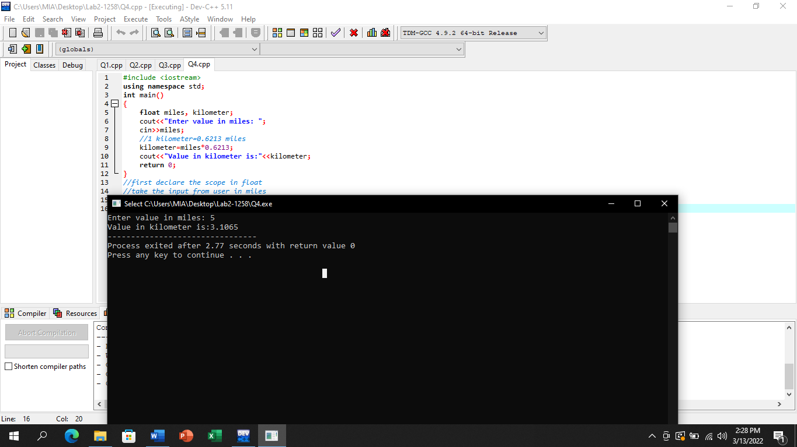

# Question No 5

## Input:

#include<iostream>

using namespace std;

int main()

{

float height,meters;

cout<<"Enter height in Feet ";

cin>>height;

//1 foot = 0.3 meters

meters=height*0.3;

cout<<"Height in meters is "<<meters;

return 0;

}

## Output:

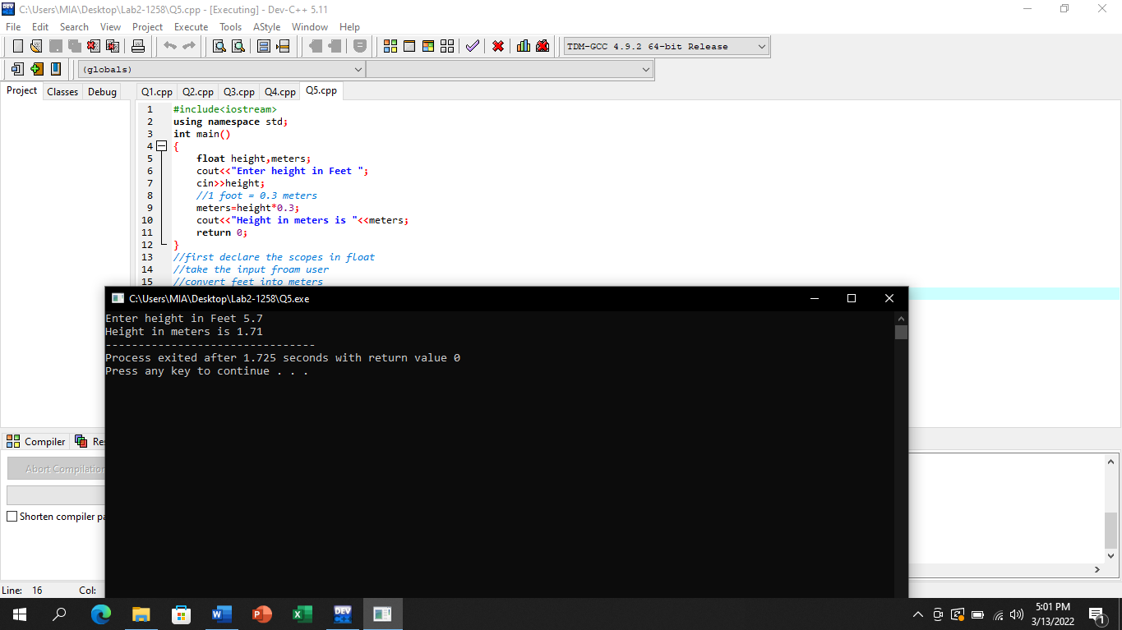

# Question No 6

## Input:

#include <iostream>

using namespace std;

int main()

{

float a=3.2, b=4.4;

cout<<"Before swapping"<<endl;

cout<<"a = "<<a<<", b = "<<b<<endl;

//Now Swapping the variables

float temp;

temp = a;

a = b;

b = temp;

cout<<"After Swapping"<<endl;

cout<<"a = "<<a <<", b = "<<b;

return 0;

}

Output: 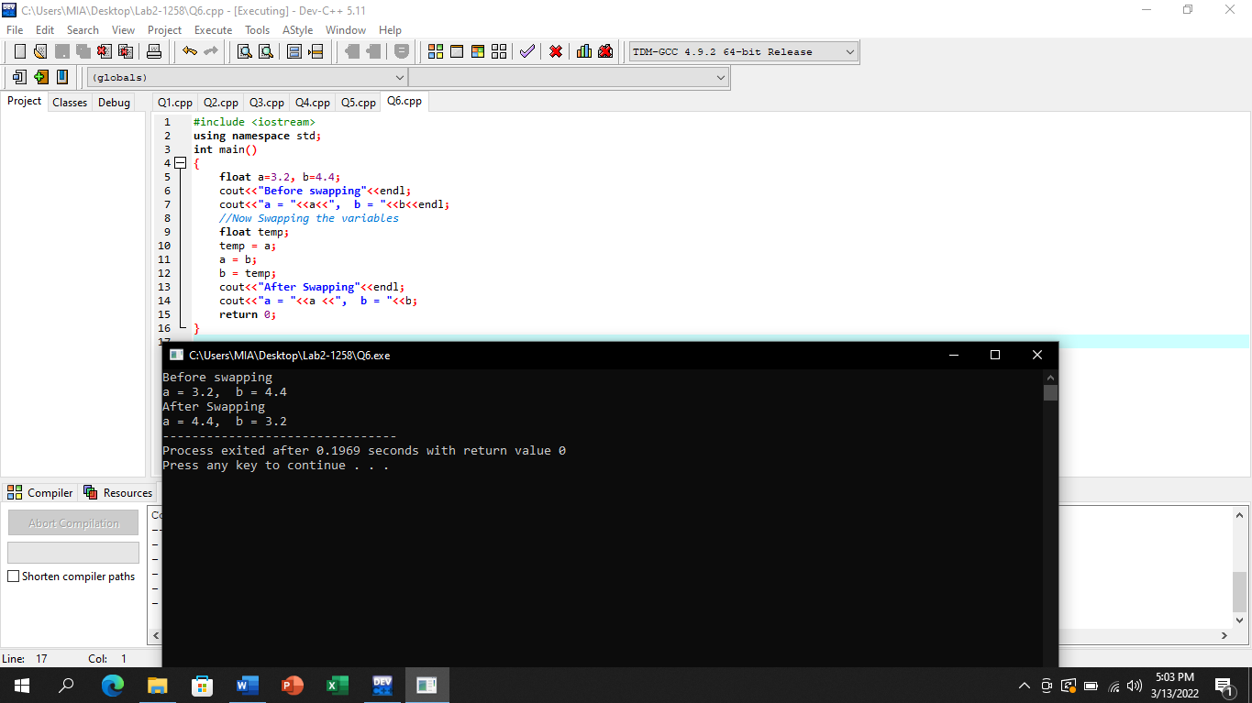

# Question No 7

## Input:

#include <iostream>

using namespace std;

int main()

{

char a= 72, b=88 ;

cout<<"Before swapping"<<endl;

cout<<"a = "<<a<<", b = "<<b<<endl;

//Now Swapping the variables

char temp;

temp = a;

a = b;

b = temp;

cout<<"After Swapping"<<endl;

cout<<"a = "<<a <<", b = "<<b;

}

## Output:

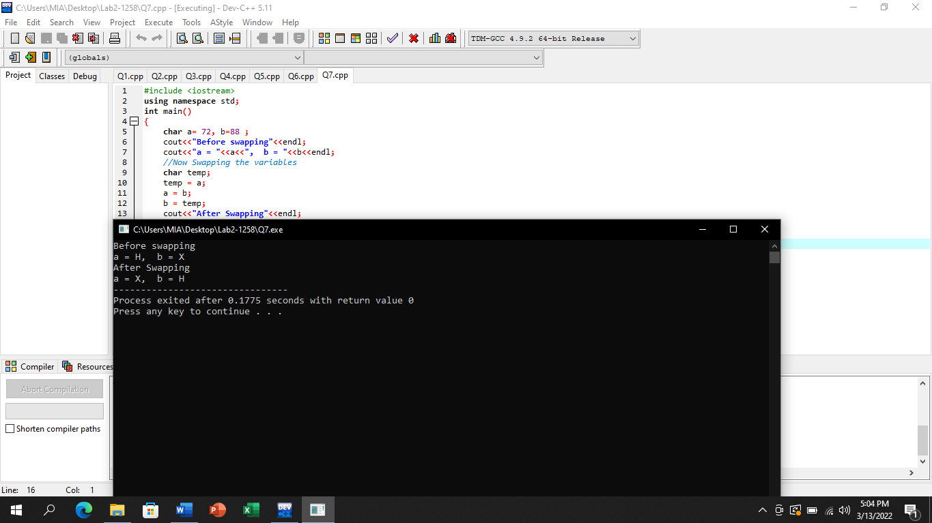

# Question No 8

## Input:

#include<iostream>

using namespace std;

int main()

{

float Pkr,Dollar,Pond,Euro;

cout<<"Input the amount in Pkr: ";

cin>>Pkr;

Dollar=Pkr/135;

cout<<"Amount in Dollar is "<<Dollar<<endl;

Pond=Pkr/170;

cout<<"Amount in Pond is "<<Pond<<endl;

Euro=Pkr/140;

cout<<"Amount in Euro is "<<Euro;

return 0;

}

Output: 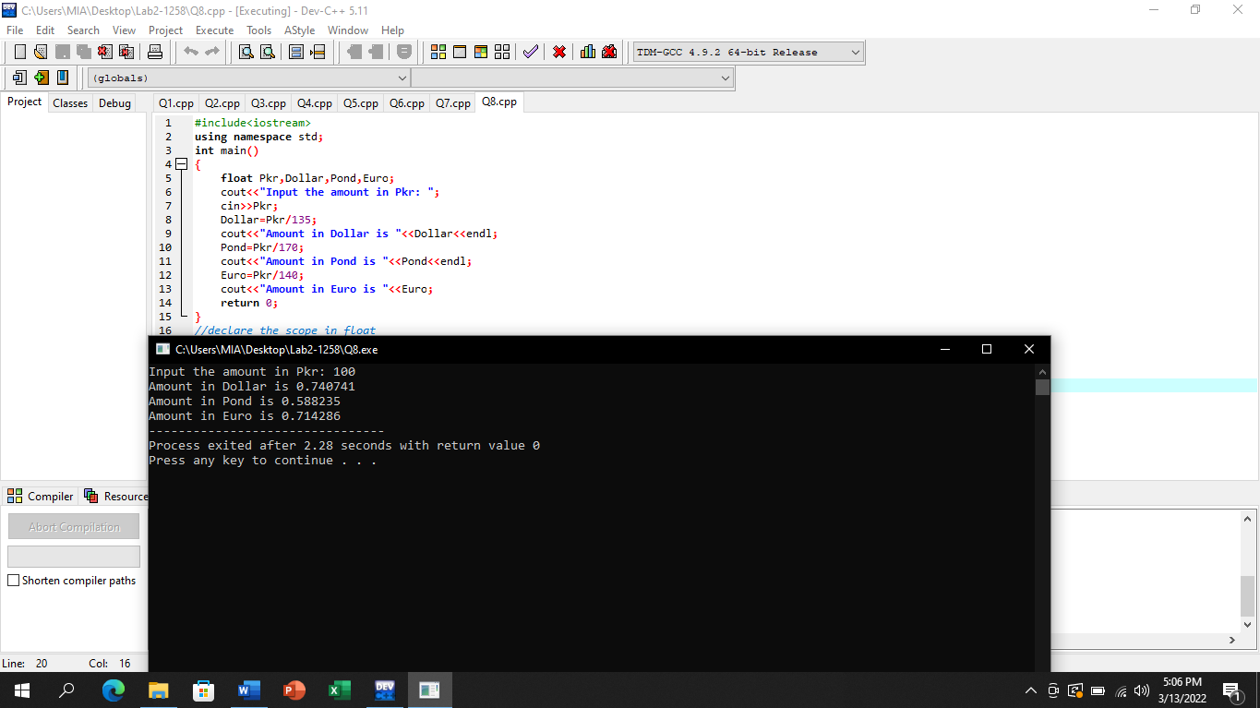

# Question No 9

## Input:

#include<iostream>

using namespace std;

int main()

{

cout<<"ASCII values are;"<<endl;

cout<<"A="<<static_cast<int>('A')<<endl;

cout<<"B="<<static_cast<int>('B')<<endl;

cout<<"C="<<static_cast<int>('C')<<endl;

cout<<"a="<<static_cast<int>('a')<<endl;

cout<<"b="<<static_cast<int>('b')<<endl;

cout<<"c="<<static_cast<int>('c')<<endl;

cout<<"0="<<static_cast<int>('0')<<endl;

cout<<"1="<<static_cast<int>('1')<<endl;

return 0;

}

## Output:

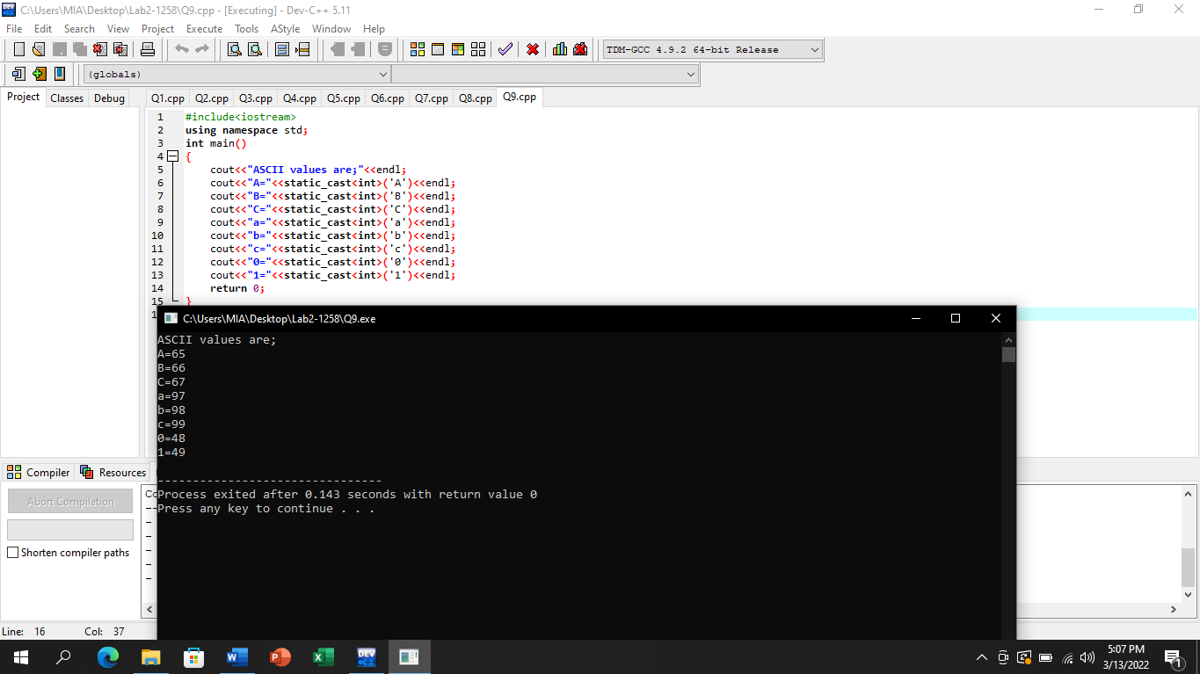

# Question No 10

## Input:

#include<iostream>

using namespace std;

int main()

{

char Character;

cout<<"Input any Character: ";

cin>>Character;

cout<<"The ASCII code of Character "<<Character<<" is "<<static_cast<int>(Character)<<endl;

return 0;

}

## Output:

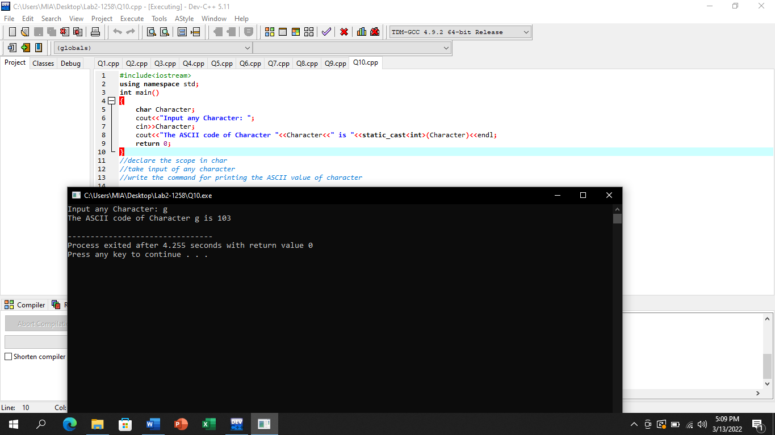

# Question No 11

## Input:

#include <iostream>

using namespace std;

int main()

{

int num,reverse_num=0;

cout<<"Enter a four digit number ";

cin>>num;

while(num!=0){

reverse_num=reverse_num*10;

reverse_num=reverse_num+num%10;

num = num/10;}

cout<<"The number in reverse order is "<<reverse_num;

return 0;

}

Output: 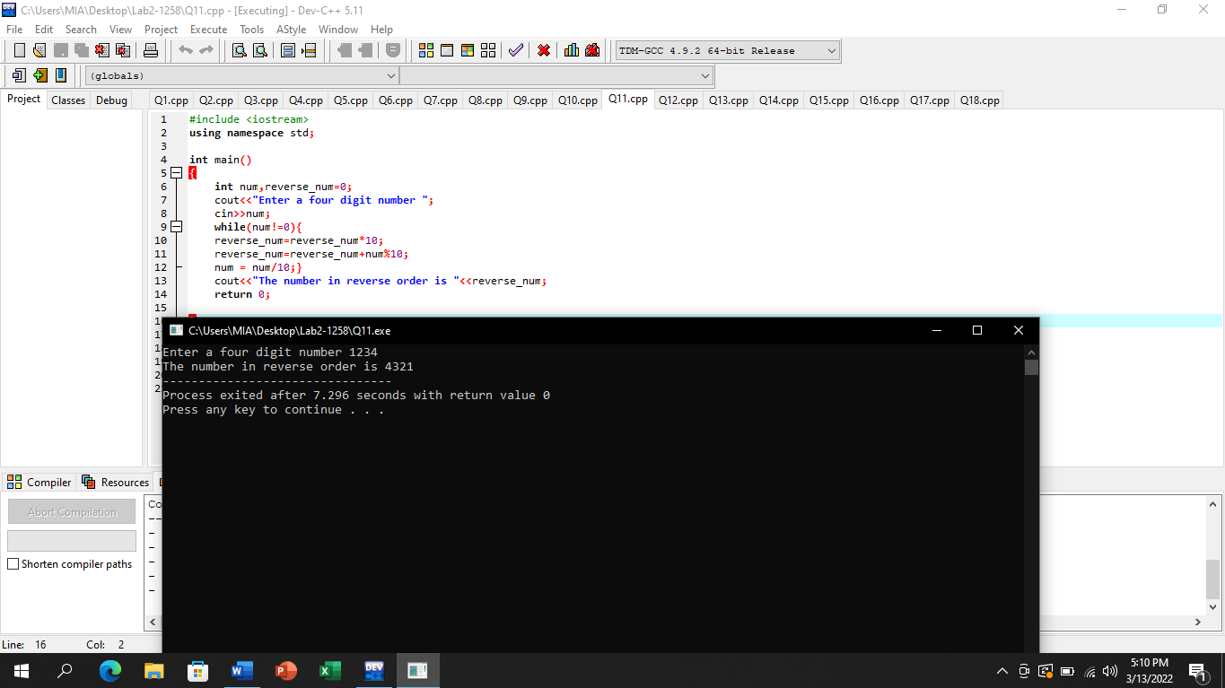

# Question No 12

## Input:

#include <iostream>

using namespace std;

int main()

{

//declare the input number as a in int

int a;

cout<<"Input a five digit number ";

cin>>a;

cout<<a/10000<<" ";

a=a%10000;

cout<<a/1000<<" ";

a=a%1000;

cout<<a/100<<" ";

a=a%100;

cout<<a/10<<" ";

a=a%10;

cout<<a<<endl;

}

## Output:

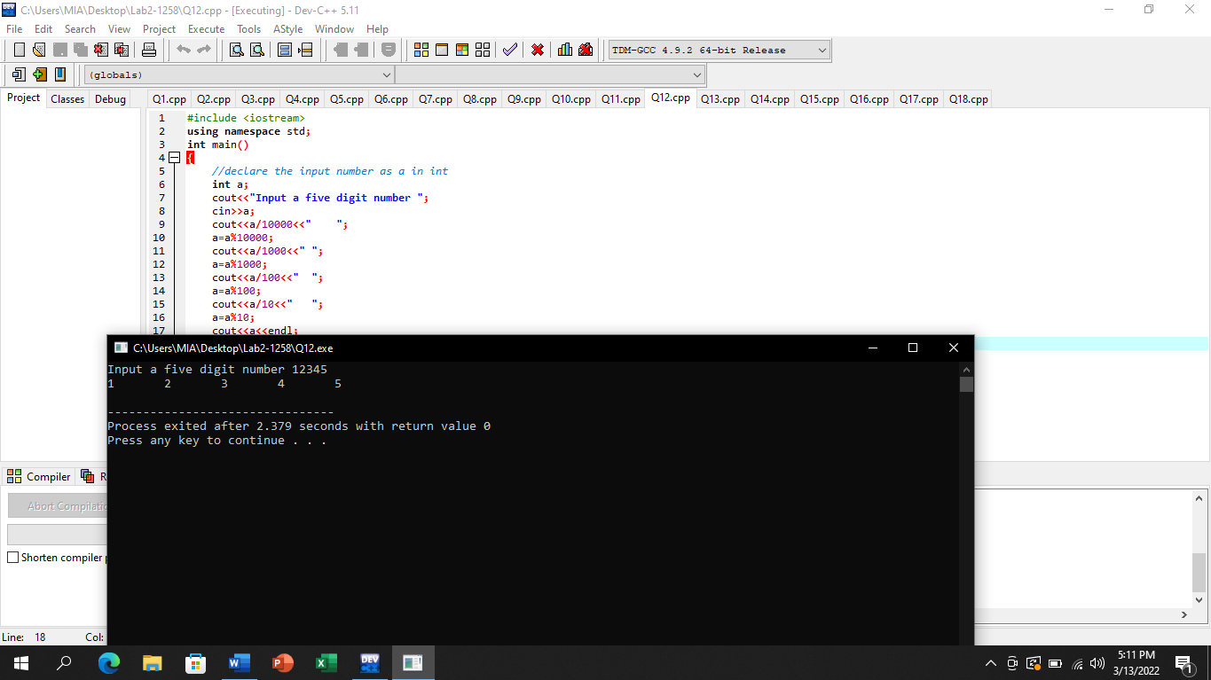

# Question No 13

## Input:

#include<iostream>

using namespace std;

int main()

{

int a,b;

cout<<"Enter first variable ";

cin>>a;

cout<<"Enter second variable ";

cin>>b;

if(a==b)

cout<<a<<" = "<<b<<endl;

if(a!=b)

cout<<a<<" != "<<b<<endl;

if(a<b)

cout<<a<<" < "<<b<<endl;

if(a>b)

cout<<a<<" > "<<b<<endl;

if(a<=b)

cout<<a<<" <= "<<b<<endl;

if(a>=b)

cout<<a<<" >= "<<b<<endl;

}

## Output:

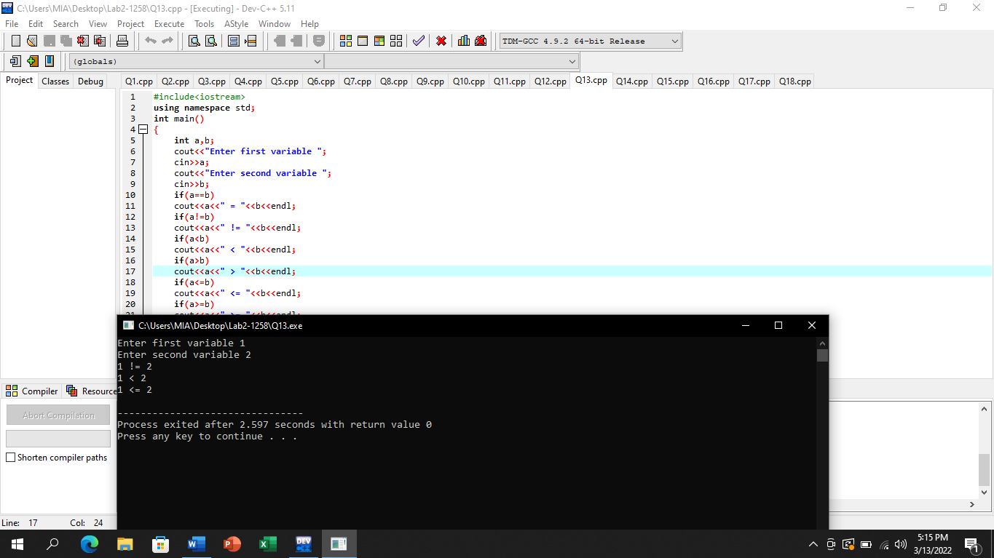

# Question No 14

## Input:

#include<iostream>

using namespace std;

int main()

{

int a,b;

cout<<"Enter first variable ";

cin>>a;

cout<<"Enter second variable ";

cin>>b;

if(a==b)

cout<<a<<" is equal to "<<b<<endl;

if(a!=b)

cout<<a<<" is not equal to "<<b<<endl;

if(a<b)

cout<<a<<" is less than "<<b<<endl;

if(a>b)

cout<<a<<" is greater than "<<b<<endl;

return 0;

}

## Output:

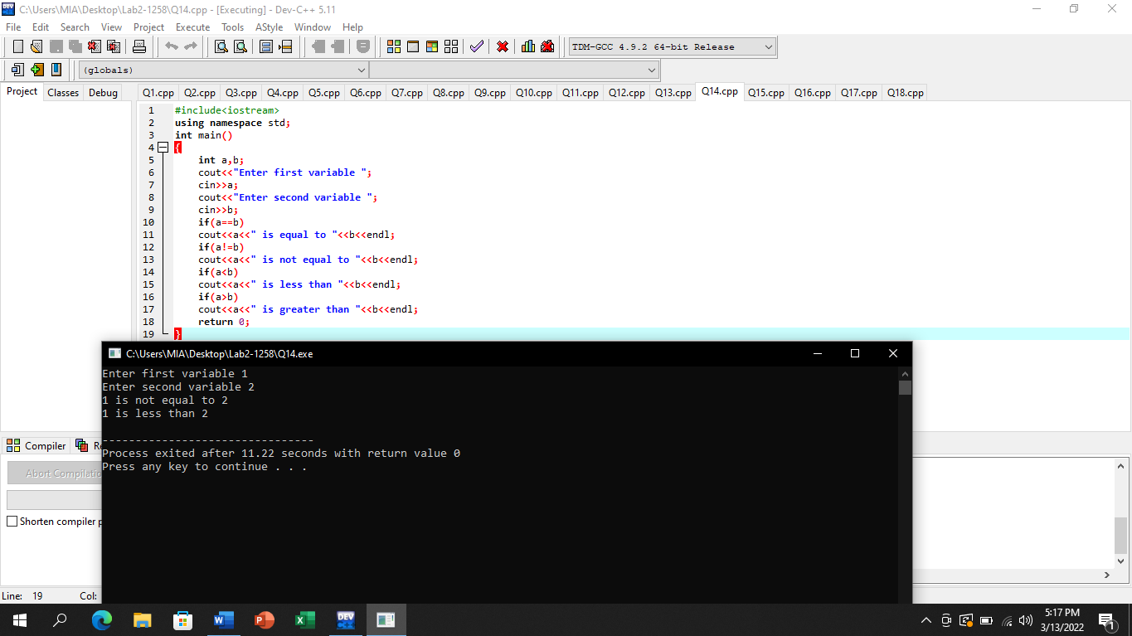

# Question No 15

## Input:

#include<iostream>

using namespace std;

int main()

{

int a;

cout<<"Enter a number_";

cin>>a;

if(a%2==0)

cout<<"Number is Even";

if(a%2!=0)

cout<<"Number is odd";

}

## Output:

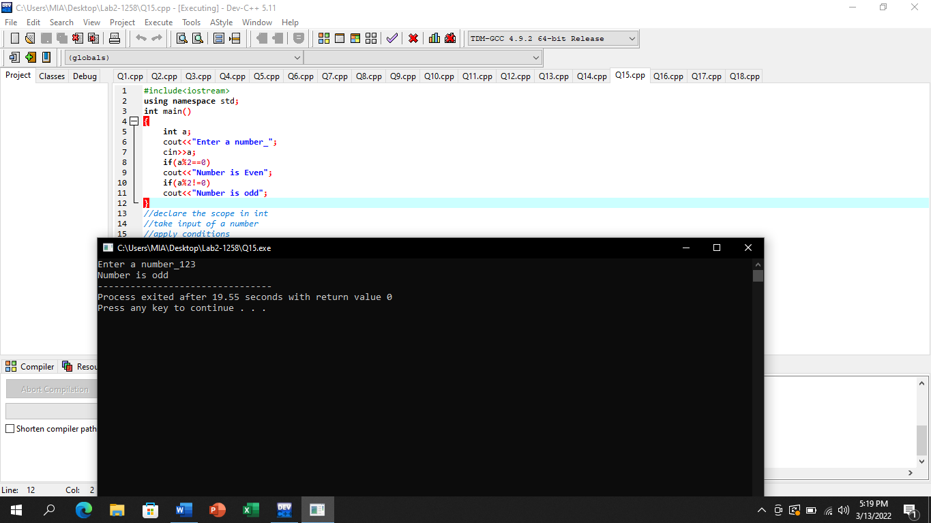

# Question No 16

## Input:

#include<iostream>

using namespace std;

int main()

{

char a;

cout<<"Enter a vowel ";

cin>>a;

if(a=='a'){

cout<<"aeroplane";}

if(a=='e'){

cout<<"elephant";}

if(a=='i'){

cout<<"integer";}

if(a=='o'){

cout<<"onion";}

if(a=='u'){

cout<<"umbrella";}

}

## Output:

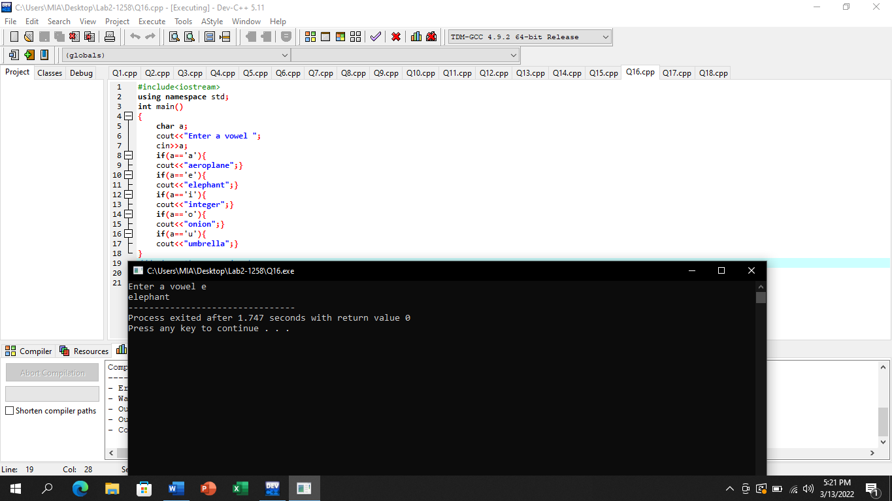

# Question No 17

## Input:

#include<iostream>

using namespace std;

int main()

{

char a;

//F for First year and L for last year

cout<<"Enter first letter of year ";

cin>>a;

if(a=='F'){

cout<<"You are a Junior";}

if(a=='L'){

cout<<"You are a Senior";}

}

## Output:

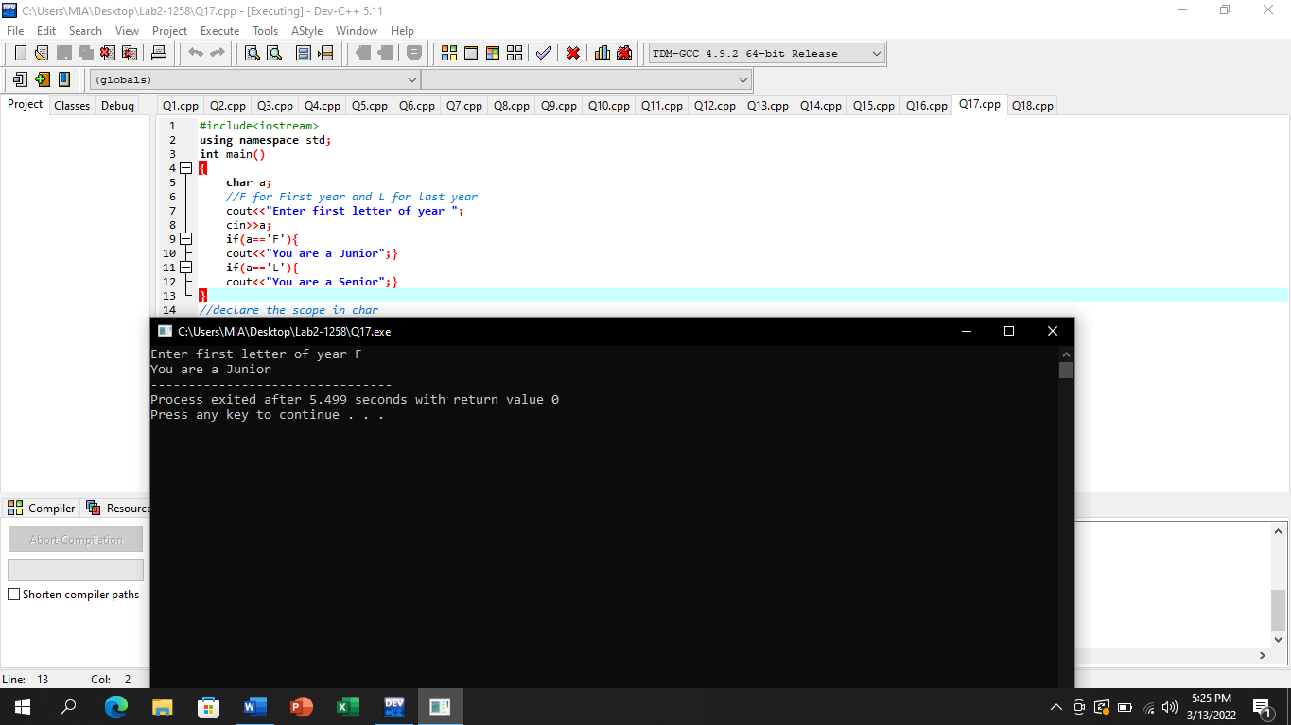

# Question No 18

## Input:

#include <iostream>

using namespace std;

int main()

{

int num,a;

cout<<"Enter four digit number ";

cin>>num;

while(num!=0){

a=a*10;

a=a+num%10;

num=num/10;

}

cout<<"The number in reverse order is "<<a<<endl;

if(a%2==0){

cout<<"The number is even";

}

if(a%2!=0){

cout<<"The number is odd";

}

return 0;

}

## Output:

